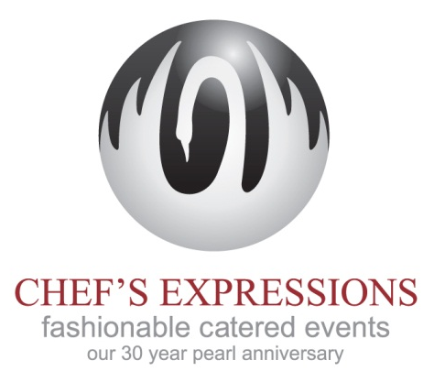
Sample Wye River Summer Wedding

BUTLER PASSED HORS D'OEUVRES

Chorizo Chopsticks
Spain meets Asia, combination of Fresh Chorizo Sausage infused with Fresh Ginger, Shallots Soy and Sweet Mirin, all Wrapped into a Spring Roll Wrapper to form a Chopstick, served with a Lebonese Garlic Sauce

Tuna Cones
Miniature Waffle Cones with Tuna Tartar, Wasabi mayo and Black Sesame Seeds

Dates and Blue Cheese, Rolled in Pistachios
Sweet Dates stuffed with Bleu Chees and rolled in Pistachios

Roasted Root Vegetable Picks
Heirloom Beets, Onions, Butternut Squash and Fingerling Potatoes Roasted in Olive Oil and finished with snipped Chives and Sea Salt

West Indies Crab Salad Spoons
Fresh Maryland Jumbo Lump Crab Meat infused with a Lemon Lime Vinaigrette with Celery, Shallots and Parsley

Beef and Beefsteak Crostini
Rare Prime Angus Loin and Robust Beefsteak Tomato on a Fork dresed with Peter Lugar Sauce

Smoked Salmon and Crisp Cucumber Spoons
Delicate Duck Trap Scottish Style Smoked Salmon married with Crisp Cool Cucumbers and a dallop of Light Creme Fraiche

SEATED SERVED DINNER

Amuse Bouche
Fresh Peach – Extra Virgin Tuscan Olive Oil with Maldon Sea Salt

Wine as Guests are Served

FIRST COURSE SERVED

Seared Diver Scallop
Served over top of a Seafood Salad with Grilled Octopus, Prawns, Celery Leaves and Tuscan Beans in a Sherry Vinaigrette

SECOND COURSE SERVED

Duck Confit Tortelloni
Tender Handmade Pasta filled with Tender Duck Confit
Served with Sweet Corn Veloute
and
Fried Leek Feathers

ENTREE

Grilled Pork Loin
Tender Pork marinated in Apple Cider and Cinnamon
Topped with Fried Pork Belly and a Preserved Lemon Sauce

Farro with Grilled Vegetables in Timbales

WEDDING CAKE

Wedding Cakes
Chef's Expressions traditional style cake with your choice of flavors presented on a plate of raspberry coulis

DESSERT BUFFET

Macaroons
Hand Made Colorful Macaroons

Hazelnut Chocolate Pot au Creme
A Gianduja blend of Hazelnut and Chocolate Whipped into a delicious Mousse and served in Clear Votive Glasses

Strawberry Landslide
Vodka Shotglass layered with Strawberry Mousse and Chantilly Cream

Lemon Curd Tartlets finished with Wild Maine Blueberries

Peanut Butter Sins

